

Spring 2026 Enrollment FAQs
Contents
I have a question related to my academic PROGRESS; how do I find an answer? 1
When Are Spring 2026 Pre- Enrollment Drop-Ins? 2
Which core are pre-enrolled vs. self-enroll? 2
How Do I request a 1000- or 2000-level core section swap? 3
I received an error code when I tried to enroll in a class, what do I do? 3
How do I access my degree audit? 3
How do I increase my credit limit? 3
What Is The Difference In Grade Options? 3
What Are Distribution Electives? 4
What is the Ethics Requirement? 5
What is the Diversity and Inclusion Requirement? 6
Which Nolan School classes meet Additional Distribution Elective Requirements? 6
how can I declare my Specialization? 7
What is a Forbidden Overlap? 7
there a hold on my account preventing enrollment - what do I do? 8
I need to register for academic accommodations. how do i do that? 8
I would like to plan to study abroad for a semester. how do i do that? 8

I have a question related to my academic PROGRESS; how do I find an answer?
- Step 1: USE YOUR RESOURCES to try to find the answer to your question independently.
  - The Hotelie LaunchPad and the Nolan Student Handbook provide information and policies related to Undergraduate Degree Audit, Practice Credit, degree requirements, and more!
- Step 2: Attend Advising Drop-Ins
  - Virtual 1:1 Drop-In sessions are offered daily throughout each semester. Details can be found on the Office of Student Services Contact Page.
- Step 3: EMAIL ha-advising@cornell.edu
  - If you cannot find the answer to your question independently, and are not available to join drop-ins, email us your question.
- Step 4: Make an appointment for a 30 minute academic advising session
  - 30-minute appointments are intended for students who wish to discuss long term goals and want to do complex planning related to those goals.
Please DO NOT make a 30-minute appointment if you have a quick question that would be better addressed during drop-ins or via email.

When Are Spring 2026 Pre- Enrollment Drop-Ins?
Spring 2026 Pre-Enrollment Drop-Ins will be held at the following times:
Monday November 10 – Friday November 21
- Mondays: 10:00am - 12:00pm
- Tuesdays: 10:00am - 12:00pm
- Wednesdays: 2:00pm - 4:00pm
- Thursdays: 2:00pm - 4:00pm
- Fridays: 10:00am - 12:00pm
All Drop-Ins are held via Zoom or in person in Statler Hall 149
Meeting ID: 946 8781 2347
Passcode: 624493

Which core are pre-enrolled vs. self-enroll?
Pre-Enrolled Core
Students are enrolled in the courses below until they are complete. First Year Students complete these courses in “Core Blocks.” Transfer Students are typically enrolled in 4 Pre-Enrolled Core Classes per semester until they are complete.
1000-Level | 2000-Level
HADM 1150 Organizational Behavior & Leadership Skills | HADM 2011 Hospitality Quantitative Analysis
HADM 1210 Financial Accounting | HADM 2220 Finance
HADM 1350 Introduction to Hotel Operations | HADM 2430 Marketing Management for Services
HADM 1361 Principles of Food & Beverage Operations Management | HADM 2810 Human Resources Management
HADM 1410 Microeconomics for the Service Industry
HADM 1650 Business Writing
HADM 1740 Business Computing

Self-Enroll Core
Students are responsible for enrolling themselves into the below courses, after they have met the pre-requisites for each course.
HADM 2021 – Critical Thinking and Mathematical Modeling (Pre-Req: HADM 2011)
HADM 2210 – Managerial Accounting (Pre-Req: HADM 1210)
HADM 2221 – Principles of Hospitality Real Estate (Pre-Req: HADM 1210 & HADM 2220)
HADM 2351 – Restaurant Management (Pre-Req: HADM 1361)
HADM 2560 – Fundamentals of Hospitality Development Management (Pre-Req: HADM 1350)
HADM 3650 – Persuasive Business Communication for Hospitality Leaders (Pre-Req: HADM 1650)
HADM 3870 – Business and Hospitality Law
HADM 4410 – Strategic Management (Pre-Reqs: HADM 1350, HADM 1410, HADM 1740, HADM 2220, HADM 2351, HADM 2430, and HADM 3650)

How Do I request a 1000- or 2000-level core section swap?
Block enrollment into core classes will take place at least one week ahead of pre-enrollment. The Core Swap Request Form will open after block enrollment takes place. If you would like to swap into a different section of a core class you are enrolled into, please do so using the Electronic Core Swap Request Form.
- While the registrar team will try to accommodate as many requests as possible, swaps are not guaranteed.
- Please do not submit duplicate requests.
- If you have questions, please email ha-registrar@cornell.edu.

I received an error code when I tried to enroll in a class, what do I do?
Refer to one of the following resources for next best steps:
- Common Student Center Enrollment Error Messages
- Common Enrollment Questions

How do I access my degree audit?
Students can access their degree audit via the link under the Registrar & Academic Resources column of Hotelie Launchpad. It is important that students check their degree audits regularly to track their progression through their degree requirements.

How do I increase my credit limit?
The default number of credits a Nolan School student can take is 18 credits (this includes PE). Students may request to take more than 18 credits if their cumulative GPA falls within the following ranges:
Cumulative GPA | Maximum credits per semester
2.501 – 2.999 | 19
3.001 – 3.499 | 20
3.500 and above | 21
Recommendation: To request an increase in credit limit in accordance with your cumulative GPA, email ha-registrar@cornell.edu at least 3 days prior to your enrollment window
- The credit limit increase is only valid for one semester and must be requested each semester as cumulative GPAs will change after grades are posted for each semester.

What Is The Difference In Grade Options?
Every class is offered for one of the following grade options:
- Letter Grade (A+ through F) exclusively
  - Passing is D- and above.
  - All core classes are offered for a letter grade only.
- Pass/Fail Exclusively (SX/UX)
  - These classes will not impact your GPA.
  - Passing grade is C- or higher.
- Student Option (S/U)
  - Students have the choice to decide whether they would like to take the class for a letter grade or pass/fail.
  - If you choose to take the class pass/fail, it will not impact your GPA.
  - Passing grade is C- or higher.
  - All classes taken Student Option pass/fail (S/U) only count toward Free Elective requirements.
Note: students are limited to enrolling in up to 4 credits S/U in a single semester. In total, students cannot exceed 8 credits total non-graded in a single semester, including both Student Option graded credits (S/U) and Satisfactory/Unsatisfactory Only (SX/UX) credits.

What Are Distribution Electives?
There are two categories for Distribution Electives:
Non-JCB Distribution Electives -- 15 credits required. You must take 3 credits minimum in at least three (3) of the following five (5) categories. These are completed through enrollment in liberal arts and sciences classes offered through any college at Cornell except the Johnson College of Business.
- Arts, Literature, and Culture & Historical Analysis (codes: ALC-AS, HST-AS, HA-HE, LAD-HE, LA-AAP, HA-AAP, ALC-AAP, HA-AG, LA-AG)​
- Global Citizenship & Social Difference (codes: GLC-AS, SCD-AS, CA-HE, CA-AAP, CA-AG, D-HE, D-AG)​
- Social Sciences (codes: SSC-AS, SBA-HE, SBA-AAP, SBA-AG)​
- Mathematics and Data Science (codes: SMR-AS, SDS-AS, MQR-AAP)​
- Biological Sciences & Physical Sciences (codes: BIO-AS, PHS-AS, PBS-HE, PBS-AAP, BIO-AG, BIOLS-AG, BIONLS-AG)​
Additional Distribution Electives – 21 credits required, including the First Year Writing Seminar (FWS)​
- Courses that meet the Liberal Arts & Sciences requirement from any College or School at Cornell, including the Nolan School.​
- External Transfer students are waived from the FWS, but still need to complete a total of 21 credits of additional distribution electives.
How to search for Distribution Electives:
- Visit the University Courses Catalog College Distribution Requirement Codes to view the complete list of all Cornell colleges’ course codes that fulfill this requirement.
- Use the search feature in the Class Roster to find distribution requirements through use of the college codes.

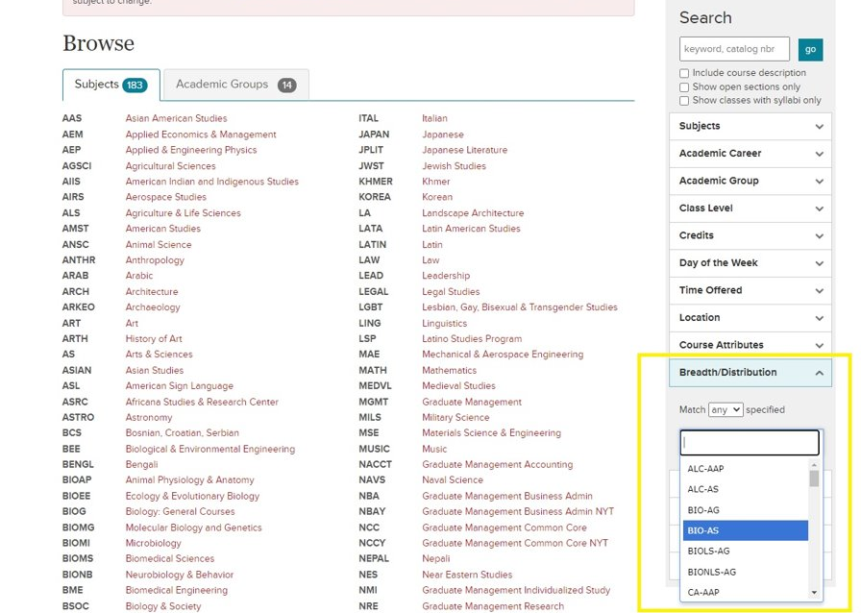

- Each course’s distribution requirement code is also listed in the full class description on the roster. If a class does not have a code listed, it does not meet distribution requirements and would not count toward either Non-JCB Distribution Elective credits or Additional Distribution Elective credits.
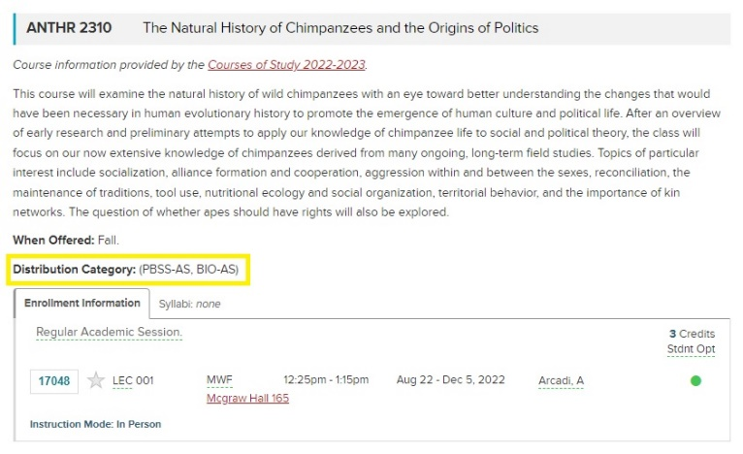

What is the Ethics Requirement?
The ethics course requirement is intended to prepare students to think critically and knowledgeably about what is (or should be) considered right or wrong, good or bad, virtue or vice within their personal, professional, and/or public lives. ​A course will be counted toward the ethics requirement if it has a notable focus/emphasis on (i.e., includes within its primary objectives) content of the following nature:
- An introduction to the philosophical study of morality, including the theory of right and wrong behavior, the theory of value (goodness and badness), the theory of virtue and vice, etc.
- An introduction to the main theories of ethics, and/or the influential philosophers within a society (e.g., John Stuart Mill's Utilitarianism and Immanuel Kant's Groundwork for the Metaphysics of Morals in Western philosophy)
- An exploration of one or more contemporary ethical/moral issues and/or contrasting ethical opinions and the reasons behind the differences
- Identifying and articulating your own values, and the ability to provide others with reasons for your actions and give you the means of questioning the values of others
- To engage in reflection and discussion to gain confidence in identifying and articulating moral problems and reasons
Please review the Nolan School Distribution Requirements webpage for the list of approved courses that meet this requirement.
If you discover a course you think may count toward this requirement and it is not listed on the Nolan School Distribution Requirements webpage, please email ha-registrar@cornell.edu to ask the registrar team for review of the course.

What is the Diversity and Inclusion Requirement?
The diversity course requirement is intended to provide students with an opportunity to explore the challenges/opportunities to an organization or community stemming from issues related to power, privilege, access, and equity. A course will be counted toward the diversity requirement if it has a notable focus/emphasis on (i.e., includes within its primary objectives) content of the following nature:
- An examination of access and equity in the context of culture, race, ethnicity, gender, sexual orientation, socio-economic status, and/or ability
- Identify the major debates within our society related to power, privilege, access, and equity and explore the relevant histories to identify/understand what has led to them
- Apply knowledge of D&I to frame, analyze, discuss, and propose sustainable solutions to contemporary issues within organizations or communities
- Exploration of aspects of diversity as potential assets for transforming and enriching organizations and communities
- An exploration of Social Identity findings and its impact on individuals’ feelings, perspectives, and experiences; and how understanding identities are linked to interpersonal and institutional levels
Please review the Nolan School Distribution Requirements webpage for the list of approved courses that meet this requirement.
If you discover a course you think may count toward this requirement and it is not listed on the Nolan School Distribution Requirements webpage, please email ha-registrar@cornell.edu to ask the registrar team for review of the course.

Which Nolan School classes meet Additional Distribution Elective Requirements?
Students can find the list of Nolan School Distribution Requirement Codes on Courses of Study. Below is a list of Nolan School classes that are currently approved to meet Additional Distribution Electives.
- HADM 4300 Introduction to Wines (ALC-HA)
- HADM 4380 Seminar in Culture and Cuisine (ALC-HA, GLC-HA)
- HADM 4375 Intro to Fermented Grains, Sake, and Cider (ALC-HA)
- HADM 4310 Food & Wine Pairing: Principles and Promotion (ALC-HA)
- HADM 4315 Nonprofit Social Enterprise & Food Justice (GLC-HA, SCD-HA)
- HADM 4815 Digital Platforms (SSC-HA)
- HADM 3610 Communication for Entrepreneurs (SSC-HA)
- HADM 4650 Advanced Communication Practicum in Public Speaking for Hospitality Leaders (SSC-HA)
- HADM 4335 Contemporary Issues in Food (SSC-HA)
- HADM 4620 Intercultural Communication for Business (GLC-HA, SSC-HA)
- HADM 3960 Leadership, Diversity, & Inclusion in the Hospitality Industry (SCD-HA)
- HADM 4500 Sustainable Development (GLC-HA)

how can I declare my Specialization?
Specializations are optional, and not required. Students can declare their Specialization via the dropdown tool in the Degree Audit.
Updated Specialization options and requirements can be found on the Minors and Specializations webpage.
Students can declare a Specialization starting in the second semester of their Sophomore year.

What is a Forbidden Overlap?
Forbidden Overlap courses are groups of courses that cover material that significantly overlaps in content.

Nolan School students WILL NOT receive credit for classes that are a Forbidden Overlap with any of their core courses. It is the student’s responsibility to confirm that they are not enrolling in any Forbidden Overlap courses, this includes core or any other course they have already taken.

In the example below, we can see that AEM 2100 is a Forbidden Overlap with one of the required Nolan School Core classes – HADM 2011. This means that Nolan Students are not eligible to receive credit for AEM 2100.

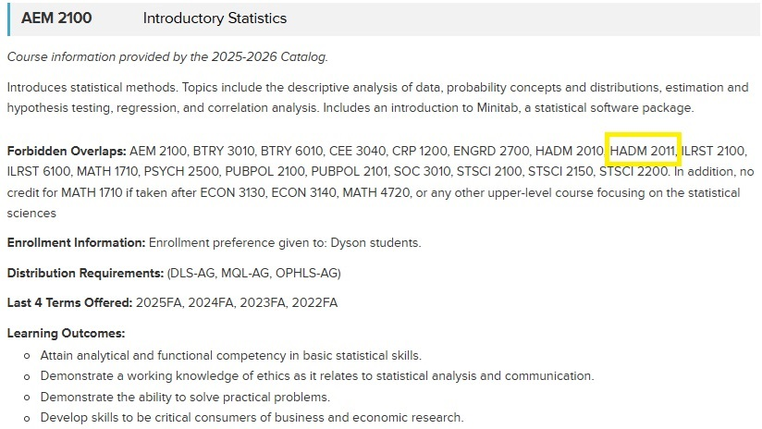

there a hold on my account preventing enrollment - what do I do?
- Step 1: Sign into your Student Center
- Step 2: Look for ‘Holds’ on the right side of the screen.
- Step 3: Click on ‘Details’ to read more about your hold(s), and instructions on how to get them removed.
- Step 4: Take the appropriate steps to get hold removed. This may include contacting the department that placed the hold.
  - If you have 1000 and/or 2000-level core remaining, please e-mail ha-registrar@cornell.edu to alert them when your hold(s) have been removed. The registrar team will NOT be able to enroll you into your 1000 and 2000 level core classes while a hold is in place. It is the student’s responsibility to notify them once a hold is cleared so they may move forward with enrolling the student in their lower-level core.

I need to register for academic accommodations. how do i do that?
Student Disability Services (SDS) provides the opportunity for you to disclose your disability status, as well as to request any needed accommodations or services.
- Step 1: Complete a Disability Self-Disclosure Form and/or a Housing Accommodation Request Form
- Step 2: Submit supporting information (if available.)
- Step 3: Make sure you submit your form!
- Step 4: After SDS reviews your information, they will follow up with you about any requested accommodations or services.
- Step 5: If an accommodation plan is created, SDS will inform you of the next steps in using your accommodations.

I would like to plan to study abroad for a semester. how do i do that?
First, review all eligibility requirements, policies, and processes listed on the NSHA Study Abroad webpage.
To be eligible to go abroad students must:
- Have a minimum cumulative GPA of 3.0 or higher.
- Complete both credits of the PE requirement.
- Complete all 1000-level and 2000-level core prior to departure.
  - Exception: Internal and External Transfers do not need to complete all 2000-level, but must have no more than 15 credits of core total remaining prior to departure
- Complete their First Year Writing Seminar.
- Be able to go abroad and still graduate on time. Students are not eligible to pursue optional programming such as a semester abroad if it means that they cannot graduate on time.
We generally recommend that students plan to reserve 15 credits of Additional Distribution Electives for their semester abroad. However, classes taken abroad may also be eligible to count toward Non-JCB Distribution Electives, the Ethics requirement, or the D&I requirement, depending on which classes are taken during the abroad program. Classes taken abroad can also count toward Free Electives. Students cannot receive credit toward Core or HADM Electives while abroad.

