The electronic core section swap process allows students enrolled in 1000-level and 2000-level HADM core courses to re- quest to swap from one course section into another section of the same course (example: request to swap from HADM 1210 Lecture 001 to HADM 1210 Lecture 002). If you are enrolled in lecture 1 of a course and would like to switch to lecture 2, the form allows us to find a student in section 2 that would like to switch to section 1. We may not be able to find a student to match your request right away which is why we will continue to accept section swap requests for Fall 2023 courses through August 24, 2023 and will notify you if/when we are able to process your swap. Please be patient and avoid submitting dupli- cate requests as that will delay processing further. **Instructions on how to use this form are listed below including how to best utilize the comments section and how to cancel a request.**

- Please click on this link: https://apps.business.cornell.edu/current-students/undergraduate/ online-forms/course-swap-request.html and log in. If you experience issues accessing the form, try a different browser. If you still have issues after trying multiple browsers, e-mail ha-resgistrar@cornell.edu. Once you log in, you should see a form that looks like this:
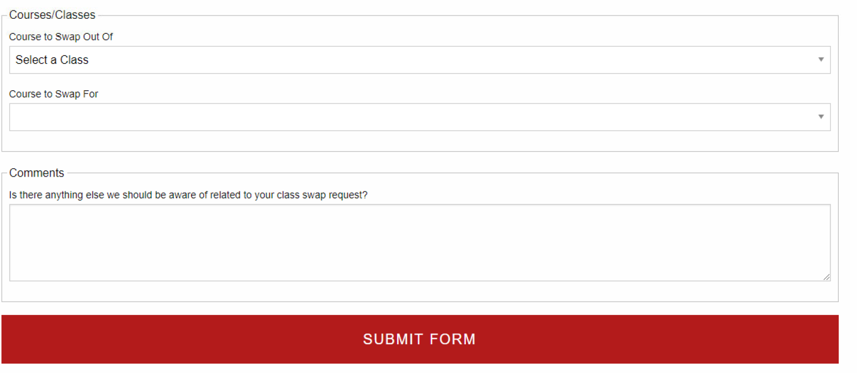

- Please select the course section you wish to swap out of from the drop down menu. Only the core course sections you are enrolled in will show up as options.
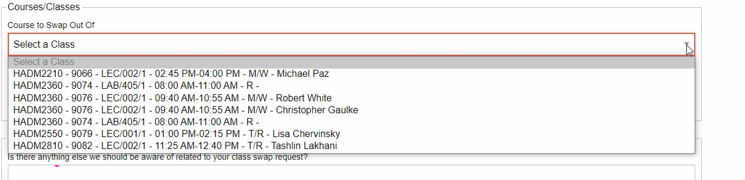

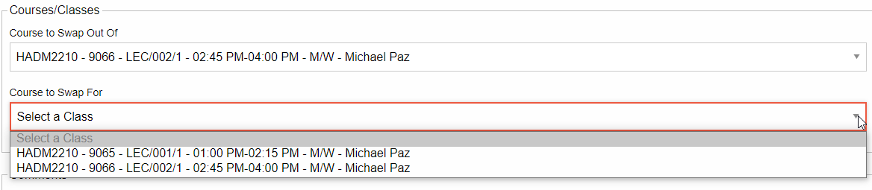
- You should then be able to select a “course to swap for” using the second drop down menu. It will only show section op- tions for the course you selected in the “course to swap out of” menu. Students cannot request to swap out of a course into a completely different course. This form is to request to swap from one course section into another section of the same course.

- Using the comments section:
Please use the comments section to also list any other information you would like us to know regarding the reasons for your request. Please especially make sure to add information in the comments section if your request falls into the following:
  - If you would like to swap sections of a class that offers 3 or more lectures/labs please use the comments section to indicate if you have a second/third choice. For example, if you would like to swap from lecture 1 to lecture 4 but lecture 3 or lecture 6 could also work for you, please submit one swap request for your first choice lecture and include in the comments your
second or third choice.
  - If your swap request requires an additional swap be processed in order to accommodate your request, please indicate that in the comments. For example, in order to change your HADM 1361 lab section you need us to also process your HADM
1150 lecture swap due to time conflicts.

- Canceling a request:
If you submit a request and change your mind at any point prior to August 24, 2023, you will need to e-mail ha-
registrar@cornell.edu and request to cancel your swap request. If your swap has already been processed by the time your e- mail is received and processed, you will need to submit a new swap request to change back to your original section. There is no guarantee that we will be able to process your request to change back to your original section so please wait to submit a swap request until you are certain you want the swap.

We will continue to accept section swap requests for Fall 2023 courses through Thursday, August 24, 2023 and will notify you if/ when we are able to process your swap. Unprocessed swap requests will remain saved through August 24, 2023 in the event
that there is an enrollment change or request update that would allow us to process your request. We will try to accommodate as many section swap requests as we are able, however submitting a request is not a guarantee that we will be able to process your request. If we are not able to process your request, you will receive an e-mail Friday, August 25, 2023 letting you know we were unable to process your request.

