Fall 2023 Enrollment FAQs
For Nolan School Students Who Matriculated in Fall 2022 or Later
Contents
I have a question related to my academic PROGRESS; how do I find an answer? 1
When Are Virtual 1:1 FA23 Pre-Enrollment Drop-Ins? 2
How Do I request a 1000- or 2000-level core section swap? 2
I received an error code when I tried to enroll in a class, what do I do? 2
How do I access my degree audit? 3
How do I increase my credit limit? 3
What Is The Difference In Grade Options? 3
What Are Distribution Electives? 4
What is the Ethics Requirement? 5
What is the Diversity and Inclusion Requirement? 5
When can I declare my Specialization? 6
What is a Forbidden Overlap? 6
there a hold on my account preventing enrollment - what do I do? 6

I have a question related to my academic PROGRESS; how do I find an answer?
- Step 1: USE YOUR RESOURCES to try to find the answer to your question independently.
  - The Hotelie LaunchPad and the Nolan Student Handbook provide information and policies related to Undergraduate Degree Audit, Practice Credit, degree requirements, and more!
- Step 2: Attend Virtual 1:1 Advising Drop-Ins
  - Virtual 1:1 Drop-In sessions are offered daily throughout each semester. Details can be found on the Office of Student Services Contact Page.
The Nolan Academic Advising Team will also be holding virtual 1:1 FA23 pre-enrollment drop-in advising times twice a day Monday April 24 – Friday May 5. See more details below.
- Step 3: EMAIL ha-advising@cornell.edu
  - If you cannot find the answer to your question independently, and are not available to join drop-ins, email us your question. Please anticipate a response time of up to 3 business days during the pre-enrollment season.
- Step 4: Make an appointment for a 30 minute academic advising session
  - 30-minute appointments are intended for students who wish to discuss long term goals and want to do complex planning related to those goals.
Please DO NOT make a 30-minute appointment if you have a quick question that would be better addressed during drop-ins or via email.

When Are Virtual 1:1 FA23 Pre-Enrollment Drop-Ins?
FA23 Pre-Enrollment Drop-Ins will be held at the following times:
- Monday April 24 – Thursday April 27
  - 10:00am – 12:00pm EST
  - 2:00pm – 4:00pm EST
- Friday April 28
  - 10:00am – 12:00pm EST
  - 2:00pm – 3:00pm EST
- Monday May 1 – Thursday May 4
  - 10:00am – 12:00pm EST
  - 2:00pm – 4:00pm EST
- Friday May 5
  - 10:00am -12:00pm EST
  - 2:00pm – 3:00pm EST

All Drop-Ins are held via Zoom
Meeting ID: 946 8781 2347
Passcode: 624493

How Do I request a 1000- or 2000-level core section swap?
Students should submit a formal request to the NSHA Registrar Team to request a swap from one pre-enrolled 1000/2000 level HADM Core course section into another section of the same course through use of the Electronic Core Swap Request Form.
- While the registrar team will try to accommodate as many requests as possible, swaps are not guaranteed.
- Please do not submit duplicate requests.
- If you have questions, please email ha-registrar@cornell.edu.

I received an error code when I tried to enroll in a class, what do I do?
Refer to one of the following resources for next best steps:
- Common Student Center Enrollment Error Messages
- Classes and Enrollment FAQ
- Guide to Fall 2023 Enrollment

How do I access my degree audit?
Students can access their degree audit via the link under the Registrar & Academic Resources column of Hotelie Launchpad. It is important that students check their degree audits regularly to track their progression through their degree requirements.

How do I increase my credit limit?
The default number of credits a Nolan School student can take is 18 credits (this includes PE). Students may request to take more than 18 credits if their cumulative GPA falls within the following ranges:
Cumulative GPA | Maximum credits per semester
2.501 – 2.999 | 19
3.001 – 3.499 | 20
3.500 and above | 21
To request an increase in credit limit in accordance with your cumulative GPA, email ha-registrar@cornell.edu at least 3 days prior to your pre-enroll window
- New external transfer students who matriculated in Spring 2023, and students whose cumulative GPA is below 2.50 may not enroll in more than 18 credits during the FA23 pre-enrollment window. These students can request to increase their credit limit prior to fall Add/Drop once grades have been posted for the spring semester, so long as their cumulative GPA is above 2.5.
- The credit limit increase is only valid for one semester and must be requested each semester as cumulative GPAs will change after grades are posted for each semester.

What Is The Difference In Grade Options?
Every class is offered for one of the following grade options:
- Letter Grade (A+ through F) exclusively
  - Passing is D- and above.
  - All core classes are offered for a letter grade only.
- Pass/Fail Exclusively (SX/UX)
  - These classes will not impact your GPA.
  - Passing grade is C- or higher.
- Student Option (S/U)
  - Students have the choice to decide whether they would like to take the class for a letter grade or pass/fail.
  - If you choose to take the class pass/fail, it will not impact your GPA.
  - Passing grade is C- or higher.
  - All classes taken Student Option pass/fail (S/U) only count toward Free Elective requirements.
Note: students are limited to enrolling in up to 4 credits S/U in a single semester. In total, students cannot exceed 8 credits total non-graded in a single semester, including both Student Option graded credits (S/U) and Satisfactory/Unsatisfactory Only (SX/UX) credits.

What Are Distribution Electives?
There are two categories for Distribution Electives:
Arts Distribution Electives -- 15 credits required. You must take 3 credits minimum in at least three (3) of the following five (5) categories. These are completed through enrollment in classes offered through the College of Arts and Sciences:​
- Arts, Literature, and Culture & Historical Analysis (coded ALC-AS or HST-AS)​
- Global Citizenship & Social Difference (coded GLC-AS or SCD-AS)​
- Social Sciences (coded SSC-AS)​
- Symbolic and Mathematical Reasoning & Statistics and Data Science (coded SMR-AS or SDS-AS)​
- Biological Sciences & Physical Sciences (coded BIO-AS or PHS-AS)​
Additional Distribution Electives – 21 credits required, including the First Year Writing Seminar (FWS)​
- Courses that meet the Liberal Arts & Sciences requirement from any College or School at Cornell, including the Nolan School.​
- External Transfer students are waived from the FWS, but still need to complete a total of 21 credits of additional distribution electives.
How to search for Distribution Electives:
- Visit the University Courses of Study to view the complete list of all Cornell colleges’ course codes that fulfill this requirement.
- Use the search feature in the Class Roster to find distribution requirements through use of the college codes.
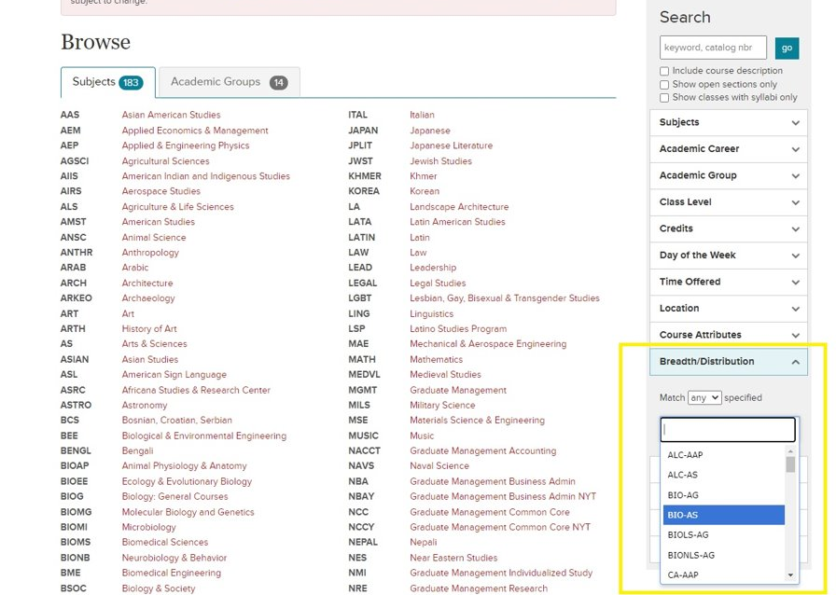

- Each course’s distribution requirement code is also listed in the full class description on the roster. If a class does not have a code listed, it does not meet distribution requirements and would not count toward either Arts Distribution Elective credits or Additional Distribution Elective credits.
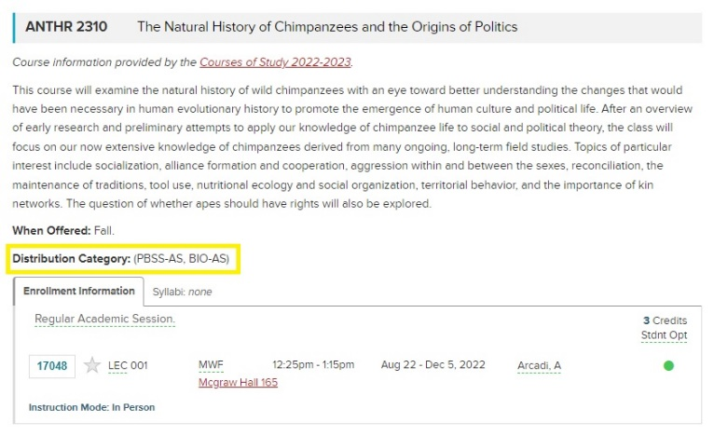

What is the Ethics Requirement?
The ethics course requirement is intended to prepare students to think critically and knowledgeably about what is (or should be) considered right or wrong, good or bad, virtue or vice within their personal, professional, and/or public lives. ​
- Approved courses that meet this requirement: ​
  - AEM 2030: Sports as Society
  - AEM 3205: Ethics in Business and Organizations ​
  - BSOC 2061: Ethics & the Environment​
  - COMM 4300: Ethics in New Media, Technology, and Communication
  - ECE 2750: Robot Ethic ​
  - ILRLR 4820: Ethics at Work​
  - INFO 4301: Ethics in New Media
  - PHIL 1450: Contemporary Moral Issues
  - PHIL 2410: Ethics ​
  - PHIL 3231: Kant’s Ethics​
  - INFO 1200: Information Ethics, Law, and Policy
  - PHIL 1440: Ethics of Eating

- If you are interested in learning more about what standards a class must meet to qualify as an Ethics course, please consult the 2022-2023 Nolan School Student Handbook.​ If you discover a course you think may count toward this requirement and it is not listed in the Student Handbook, please email ha-registrar@cornell.edu to ask the registrar team for review of the course.

What is the Diversity and Inclusion Requirement?
The diversity course requirement is intended to provide students with an opportunity to explore the challenges/opportunities to an organization or community stemming from issues related to power, privilege, access, and equity.

- Approved courses:
  - HADM 3960: Seminar in Leadership, Diversity, and Inclusion
  - AEM 2015: The Business Case for Diversity and Inclusion
  - AEM 3015: Developing Racial Equity in Organizations
  - AMST 1104: Race and Ethnicity in the United States: Social Constructs Real World Consequences
  - AMST 2505/FGSS 2501: Playing out Difference: History and Identity in Sports Film
  - ANTHR 2470: Island and Gender
  - ANTHR 3487: Racial Capitalism
  - ASIAN 2230/CAPS 2230: Introduction to China: Outsiders in History
  - EDUC 2610: Intergroup Dialogue
  - FGSS 2010: Introduction to Feminist, Gender, and Sexuality Studies
  - FGSS 2290: LBGTQ Mental Health
  - FGSS 2501: Playing out Difference: History and Identity in Sports Film
  - ILRHR 3640: Diversity & Inclusion
  - ILRID 2510: Foundations of Diversity Dynamics
  - NTRES 2000: Environmental Justice
  - PHIL 1650: Philosophy of Race
- If you are interested in learning more about what standards a class must meet to qualify as a Diversity & Inclusion course, please consult the 2022-2023 Nolan School Student Handbook.​ If you discover a course you think may count toward this requirement and it is not listed in the Student Handbook, please email ha-registrar@cornell.edu to ask the registrar team for review of the course.

When can I declare my Specialization?
Students can declare their specialization as early as the first semester of their second year. All students will be able to modify their specialization selection up until the University Add deadline date of the first semester of their senior year.

What is a Forbidden Overlap?
Forbidden Overlap courses are groups of courses that cover material that significantly overlaps in content. Review the 2022-2023 Forbidden Overlap List to find courses that, due to an overlap in content, students will receive credit for only one course in each of the groups listed.

Nolan School students WILL NOT receive credit for classes that are a Forbidden Overlap with any of their core courses. It is the student’s responsibility to confirm that they are not enrolling in any Forbidden Overlap courses, this includes core or any other course they have already taken.

there a hold on my account preventing enrollment - what do I do?
- Step 1: Sign into your Student Center.
- Step 2: Look for ‘Holds’ on the right side of the screen.
- Step 3: Click on ‘Details’ to read more about your hold(s), and instructions on how to get them removed.
- Step 4: Take the appropriate steps to get hold removed. This may include contacting the department that placed the hold.
  - If you have 1000 and/or 2000-level core remaining, please e-mail ha-registrar@cornell.edu to alert them when your hold(s) have been removed. The registrar team will NOT be able to enroll you into your 1000 and 2000 level core classes while a hold is in place. It is the student’s responsibility to notify them once a hold is cleared so they may move forward with enrolling the student in their lower-level core.

