Spring 2023 Enrollment FAQs
For Nolan School Students Who Matriculated in Fall 2022 or Later
Contents
I have a question related to my academic progress, how do I find an answer? 1
When are Virtual 1:1 Add/Drop Drop-Ins? 2
How do I request a core section swap? 2
I got an error code when I tried to enroll in a class, what do I do? 2
How do I access my degree audit? 3
How do I increase my credit limit? 3
What are the different grade options? 3
How do I find Distribution Electives? 4
What classes can count toward the Ethics Requirement? 5
What classes can count toward the Diversity and Inclusion Requirement? 5
When can I declare my Specialization? 6
I have a hold on my account that’s preventing me from enrolling, what do I do? 6

I have a question related to my academic progress, how do I find an answer?
If you have a question, please follow the process below!
- Step 1: Use your resources to try to find the answer to your question independently.
  - Please refer to the Hotelie LaunchPad, and Student Handbook for information regarding your Undergraduate Degree Audit, Practice Credit policies and degree requirements
- Step 2: Attend Virtual 1:1 Advising Drop-Ins
  - Weekly Semester Long Virtual 1:1 Drop-In Details can be found on the Office of Student Services Contact Page. The Academic Advising Team will be holding daily virtual 1:1 pre-enrollment drop-ins twice a day October 31 – November 11. Details are below.
- Step 3: Email ha-advising@cornell.edu
  - If you cannot find the answer to your question independently, and are not available to join drop-ins, email us your question. Please note – Taylor Sweazey is currently the only academic advisor at the Nolan School. She will try to answer all questions as quickly as possible, but please anticipate a response time of up to 3 business days.
- Step 4: Make an appointment for individual 30 minute academic advising session
  - 30 minute appointments are intended for students who wish to discuss long term goals and want to do complex planning related to those goals. Please do not make a 30 minute appointment if you have a quick question that would be better addressed during drop-ins or via email

When are Virtual 1:1 Pre-Enrollment Drop-Ins?
We will be holding Virtual 1:1 Pre-Enrollment Drop-Ins at the following times:
- Tuesday January 17 – Thursday January 19
  - 10:00am – 12:00pm EST
  - 2:00pm – 4:00pm EST
- Friday January 20
  - 10:00am – 12:00pm EST
  - 2:00pm – 3:00pm EST
- Monday January 23 – Thursday January 26
  - 10:00am – 12:00pm EST
  - 2:00pm – 4:00pm EST
- Friday January 27
  - 10:00am -12:00pm EST
  - 2:00pm – 3:00pm EST

Drop-Ins are held via Zoom
Meeting ID: 946 8781 2347
Passcode: 624493

How do I request a core section swap?
Students can submit a formal request to the NSHA Registrar Team to swap from one pre-enrolled 1000/2000 level HADM Core course section into another section of the same course through use of the Electronic Core Swap Request Form
- Swaps are not guaranteed, but the registrar team will try to accommodate as many requests as possible.
- Please do not submit duplicate requests
- If you have questions, please email ha-registrar@cornell.edu

I got an error code when I tried to enroll in a class, what do I do?
Refer to one of the following resources for next best steps:
- Common Student Center Enrollment Error Code Messages
- University Registrar Guide to Spring 2023 Enrollment

How do I access my degree audit?
Students can access their degree audit via the link under the Registrar & Academic Resources column of Hotelie Launchpad. It is important that students check their degree audits regularly to track their progression through their degree requirements.

How do I increase my credit limit?
The default number of credits a Nolan School student can take is 18 credits. Students may request to take more than 18 credits if their cumulative GPA falls within the following ranges:
Cumulative GPA | Maximum credits per semester
2.501 – 2.999 | 19
3.001 – 3.499 | 20
3.500 and above | 21
In order to request an increase in credit limit in accordance with your cumulative GPA, email ha-registrar@cornell.edu
- New full time first semester students (including external transfer students) and students whose cumulative GPA is below 2.50 may not enroll in more than 18 credits during the pre-enrollment window. These students can request to increase their credit limit once grades have been posted for the fall semester, allowing them to enroll in more than 18 credits during the Add/Drop window, so long as their cumulative GPA is above 2.5.
- The credit limit increase is only valid for one semester and must be requested each semester as cumulative GPAs will change after grades are posted for each semester

What are the different grade options?
Every class is offered for one of the following grade options:
- Letter Grade (A+ through F) exclusively
  - Passing is D- and above
  - All core classes are offered for a letter grade only
- Pass/Fail Exclusively (SX/UX)
  - These classes will not impact your GPA
  - Passing grade is C- or higher
- Student Option (S/U)
  - Students have the choice to decide whether they would like to take the class for a letter grade or pass/fail
  - If you choose to take the class pass/fail, it will not impact your GPA
  - Passing grade is C- or higher
  - All classes taken Student Option pass/fail (S/U) can only count toward Free Electives
Note: students are limited to take up to 4 credits S/U in a single semester. In total, students cannot exceed 8 credits total non-graded in a single semester, including both Student Option graded credits (S/U) and Satisfactory/Unsatisfactory Only (SX/UX) credits.

How do I find Distribution Electives?
There are two categories for Distribution Electives:
Arts Distribution Electives -- 15 credits. You must take 3 credits minimum in at least 3 of the following 5 categories in the College of Arts and Sciences:​
- Arts, Literature, and Culture & Historical Analysis (coded ALC-AS or HST-AS)​
- Global Citizenship & Social Difference (coded GLC-AS or SCD-AS)​
- Social Sciences (coded SSC-AS)​
- Symbolic and Mathematical Reasoning & Statistics and Data Science (coded SMR-AS or SDS-AS)​
- Biological Sciences & Physical Sciences (coded BIO-AS or PHS-AS)​
Additional Distribution Electives – 21 credits total, including First Year Writing Seminar (FWS)​
- Courses that meet the Liberal Arts & Sciences requirement from any College or School at Cornell, including the Nolan School.​
- External Transfer students are waived from the FWS, but still need to complete 21 credits total ​
How to search for Distribution Electives
- Visit the Courses of Study (PLEASE BOOKMARK THIS WEBSITE for future reference) to view the complete list of all Cornell colleges’ course codes that meet this requirement
- Search the Class Roster for classes that meet distribution requirements through use of the college codes
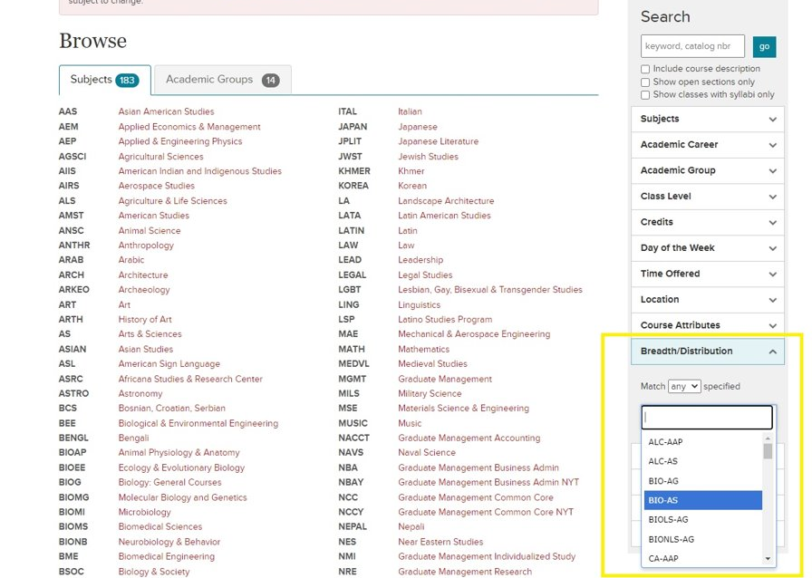

- Each course’s distribution requirement code is listed in the full class description on the roster. If a class does not have a code, it does not meet distribution requirements and would not count toward either Arts Distribution Elective credits or Additional Distribution Elective credits
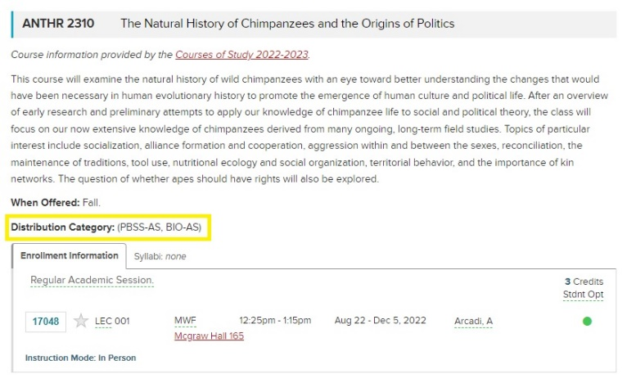

What classes can count toward the Ethics Requirement?
The ethics course requirement is intended to prepare students to think critically and knowledgeably about what is (or should be) considered right or wrong, good or bad, virtue or vice within their personal, professional, and/or public lives. ​
- Example courses: ​
  - PHIL 2410: Ethics ​
  - AEM 3205: Ethics in Business and Organizations ​
  - BSOC 2061: Ethics & the Environment​
  - PHIL 3231: Kant’s Ethics​
  - ILRLR 4820: Ethics at Work​
  - ECE 2750: Robot Ethic ​
- If you are interested in learning more about what standards a class must meet to qualify as an Ethics course, please consult the 2022-2023 Nolan School Student Handbook.​ If you find a course you think should count toward this requirement and it is not listed in the Student Handbook, please email ha-registrar@cornell.edu to ask the registrar team to review the course

What classes can count toward the Diversity and Inclusion Requirement?
The diversity course requirement is intended to provide students with an opportunity to explore the challenges/opportunities to an organization or community stemming from issues related to power, privilege, access, and equity
- Example courses:
  - HADM 3960: Seminar in Leadership, Diversity, and Inclusion
  - ILRHR 3640: Diversity & Inclusion
  - AEM 3015: Developing Racial Equity in Organizations
  - FGSS 2010: Introduction to Feminist, Gender, and Sexuality Studies
  - ANTHR 3487: Racial Capitalism
  - NTRES 2000: Environmental Justice
- If you are interested in learning more about what standards a class must meet to qualify as a Diversity & Inclusion course, please consult the 2022-2023 Nolan School Student Handbook.​ If you find a course you think should count toward this requirement and it is not listed in the Student Handbook, please email ha-registrar@cornell.edu to ask the registrar team to review the course

When can I declare my Specialization?
Transfer students can declare their Specialization as early as Spring 2023. First Year Students can declare their specialization starting first semester of their sophomore year. All students will be able to modify their specialization selection up until the start of the first semester of their senior year

I have a hold on my account that’s preventing me from enrolling, what do I do?
- Step 1: To check your holds, first sign into your Student Center
- Step 2: Next, check for ‘Holds’ on the right side of the screen
- Step 3: Click on ‘Details’ to read more about your hold(s), and instructions on how to get them removed
- Step 4: Take the appropriate steps to get hold removed
  - If you have 1000 and/or 2000-level core remaining, please e-mail ha-registrar@cornell.edu to announce you have had your hold(s) removed. If you still have lower-level core remaining and a hold is on your account during block enrollment of core classes, the registrar team will not be able to enroll you into your core classes. They will not know that your hold has been removed and that they can move forward with enrolling you in lower-level core unless you email to notify them.

